STARTUP PROCEDURE – EROSION RIG

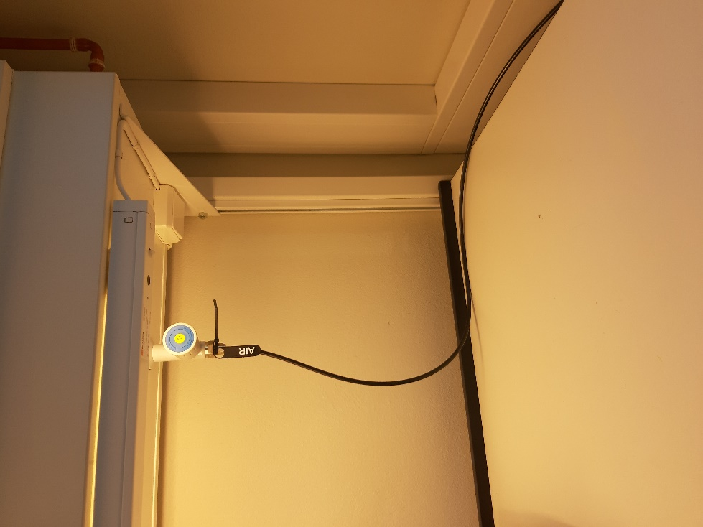

1. Open valves **V105**, **V106** & **V107** (*pump reflux*)

2. Make sure that the air valve (**AIR**) is turned off.

The valve is behind you

off

on

3. Connect **220 AC** and **3-phase** cables. *You find the cables (with labels) under the cabinet. The plugs are on the wall behind the tank.*

4. Connect the 3 **USB**’s cables to the PC.

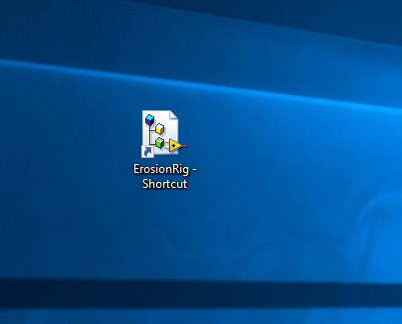

5. Turn on the computer (password: labuser1) and click on the LabVIEW icon

Open *“ErosionRig – Flow ctrl.vi”*; and make sure that the setpoints have sensible values:

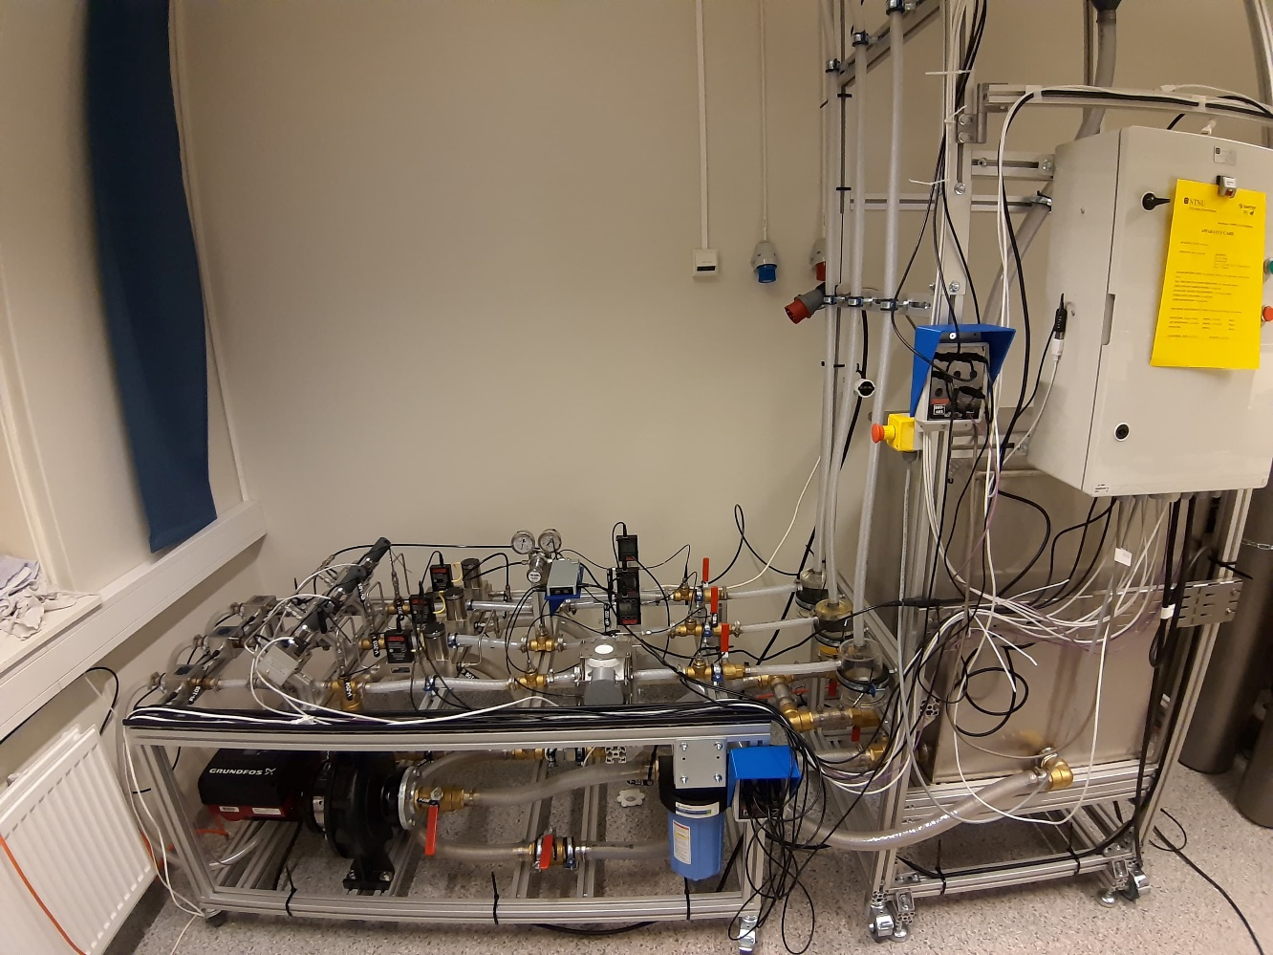

Page 1/2

**USB cables**

**3-phase plug**

**220AC plug**

**V105**

**V107**

**V106**

Page 1/2

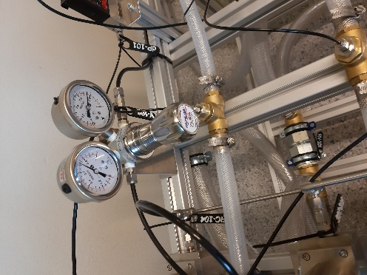

6. Turn on air valve from Step 2 (**AIR**)

7. Turn on pressure regulator **V108**

*(clockwise – on | counter-clockwise – off )*

8. Turn on the cabinet using the **green button** (*outside*)

on

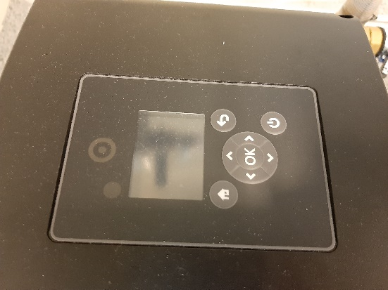

9. Start the LabVIEW program by pressing the white arrow

10. Turn on the pump

11. Open valves **V102, V103 & V104** (*any order*)

Pump panel

12. Open valve **V101**



**CABINET**

**V108**

**V102, V103, V104**

**V101**

**PUMP**

page 2/2 *END*